MMA Housing Information
Hartford Marriott Downtown
Logo:

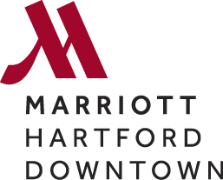

Reservation Link: https://book.passkey.com/go/MMA56
Rate: $119.00
Suite Rate: $499.00
Distance from Center: Attached

The Goodwin Hotel
Logo:
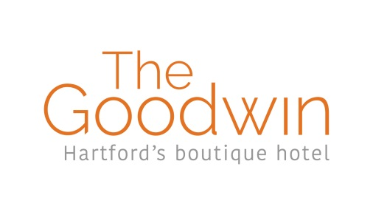

Call (860) 246-1881 to make Reservation
Rate: $149/$179.00
Suite Rate: 259.00
Distance from Center: 0.7 Miles, 4 Minutes

Holiday Inn Hartford Downtown Area
Logo:
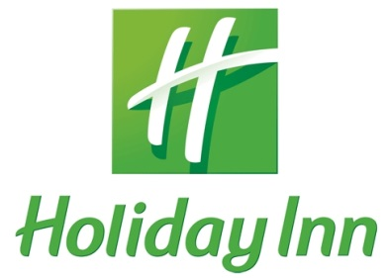

Reservation Link: https://www.holidayinn.com/redirect?path=hd&brandCode=HI&localeCode=en&regionCode=1&hotelCode=EHTHI&_PMID=99801505&GPC=MMA&cn=no&viewfullsite=true.
Rate: $89.00
Suite Rate: $159.00
Distance from Center: 1.2 Miles, 3 Minutes

Hilton Garden Inn Hartford South/Glastonbury
Logo:
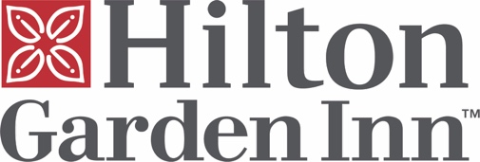

Reservation Link: https://secure3.hilton.com/en_US/gi/reservation/book.htm?inputModule=HOTEL&ctyhocn=BDLGHGI&spec_plan=CSEMMA&arrival=20190531&departure=20190601&cid=OM,WW,HILTONLINK,EN,DirectLink&fromId=HILTONLINKDIRECT
Rate: $139.00
Distance from Center: 5.4 Miles, 8 Minutes

