


The 43rd Annual CMTA Hartford Boat Show sails back to Hartford and to the Connecticut Convention Center January 27-29, 2012!

Show Hours: Friday, January 27, 2012 12 PM-9 PM
Saturday, January 28, 2012 10 AM-9 PM
Sunday, January 29, 2012 10 AM-5 PM

Ticket Pricing: Adults: $12.00
Children: Under 12 are FREE with an adult

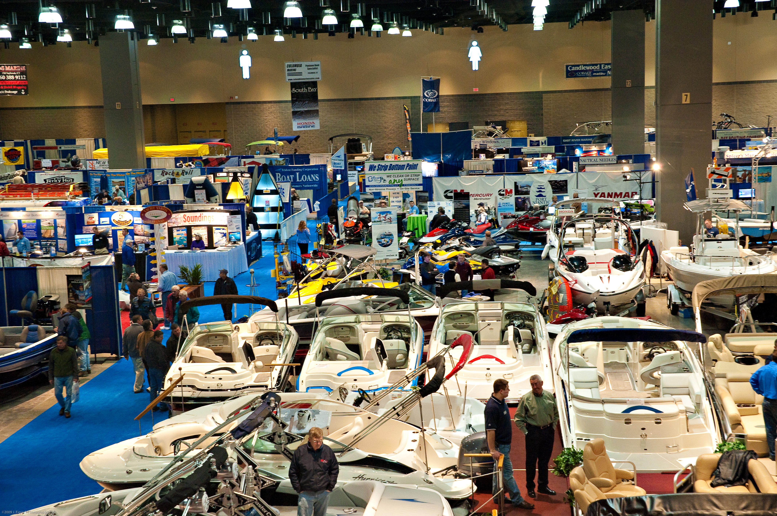
Show Features: The CMTA Hartford Boat Show returns to the Connecticut Convention Center with the area’s best selection of watercrafts and accessories! The show will feature dozens of FREE seminars along with a chance to win one of two boats!! It is the ideal place for boaters and families who are looking to purchase their first watercraft, looking to upgrade their present cruiser or for the veteran boaters to explore new adventures.

This event is presented by EVINRUDE along with the following sponsors: the River 105.9, NBC Connecticut, and Country 92.5

A boatload of vendors and hundreds of vessels will provide attendees with literature and information about “getting off your dock and making your summer rock!”

For additional information, please visit www.hartfordboatshow.com

